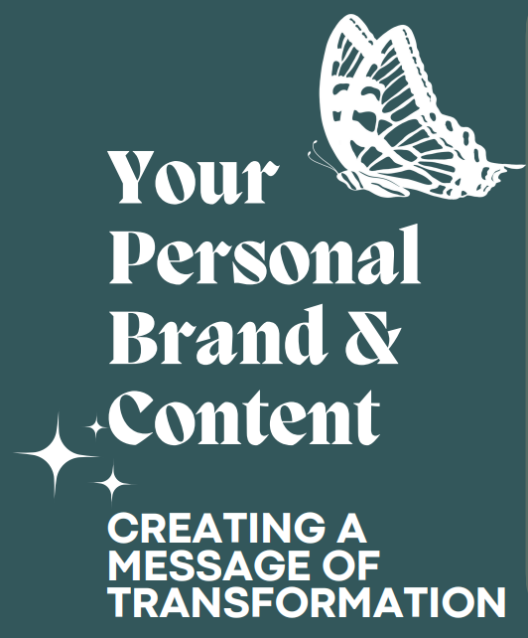

Part 1 ~ Why Personal Branding Matters

- Builds credibility

- Opens opportunities

- Fosters connections

QUESTIONS:

- What’s your super power?

Super power questions:
- What have I trained in?
- What skills do I have?
- What was I born with?
- Passions/desires?

- Personal stories

Super power questions:
- What experiences have shaped who you are today?
- What challenges have you overcome?
- How can you use your story to connect with others and build authenticity?

- The principle of giving to receive

Super power questions:
- What can you share to add value?
- How can you help educate your audience?
- What can you do to inspire your followers?

Part 2 ~ Why Content Creation Matters

CARE + SERVE = TRANSFORMATION

C – Connections and community
Connect with others, build your community

A – Authentic
Be authentic, share who you really are

R – Relationships
Create positive relationships

E – Essence of your message
Creating content on LinkedIn:
- What do you want people to know about you?
- Is it clear who you are and who you serve?
- What is your content about? What are you sharing?
- If someone wanted to quote you by looking at your LinkedIn content, would they be able to?

S – Serve
Serve others through your content

E – Encourage
By sharing your story, you can encourage others

R – Relational
Build relationships by making business friends

V – Value
Focus on your zone of genius: Give value

E - Engage
Look at the last 10 posts on your LinkedIn page:
- What will people discover about you?
- Will they know who you are, who you serve?
- Do your posts share your personality as well as what your business is about?
- Are you posting your own content or reposting someone else’s post?

When you care about and serve others, you can create a transformation!

Use your content to start making positive connections and build a community of BUSINESS FRIENDS!

Connect with us:
Trae Bohlen – https://www.linkedin.com/in/traebohlen/
Val Roskens Tews – https://www.linkedin.com/in/val-roskens-tews/

